Lab Exercise 13 Student Name: ChenYu Yang Student ID: 1670203

Download the source file, MultipleBallApp.java. Preview the document, from the "demo files" folder under Files. Run the source file from your IDE.

Review the source file, discuss with your peer and answer the following questions:

1. How many class files will be generated from the source file?

***Answer:*** The 3 class files will be generated from the source file.

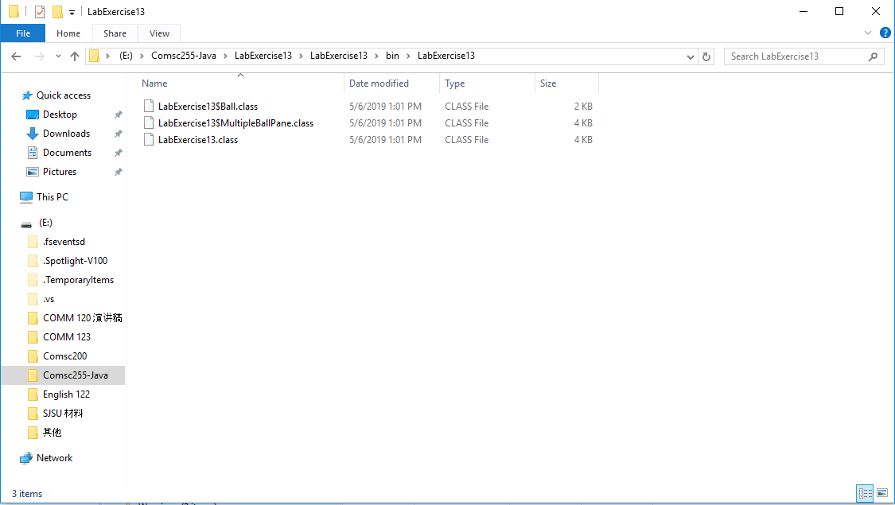

2. Review the source content of the MultipleBallPane class. Why the MultipleBallPane class is set to private? Can we change it? How will it affect the code design?

***Answer:*** If it's not needed outside the class it is in at that very moment, make it to "private". If later we discover that some other class needs access to a private function, at that point we need to change it to "public". As for this question, we do not need to use the MultipleBallPane class outside the class, so the MultipleBallPane class is set to private. And public means you can access it anywhere while private means you can only access it inside its own class. So I think in this file we can be change it. The impact is just make other class can access to MultipleBallPane class.

3. Review the source content of the void method moveBall(). Why the void method moveBall() is set to protected? Can we change it? How will it affect the code design?

***Answer:*** The protected class is visible to the package and all sub-classes. In this file, every protected class need to use moveBall(), So I think moveBall() is set to protected. But I think we also can change it. The public class is visible to the world and the private class is visible to the class only. So if we change protected class to public or private, the impact is other class can access moveBall().